**SC531 PROBABILITY & RANDOM VARIABLES**

**RETEST (12 marks, 40 minutes)**

Q-1. A university has 1000*M students. 40% of the students are from rural background, and 40% of the students are active in sports. Half of the students from rural background are also active in sports. If a randomly selected student is NOT active in sports, what is the probability that he or she is from a rural background?

pdf of continuous RV X

X = 0 X = 10 X = 20 X axis 🡪

Q-2. Given the probability density function shown above, find Prob( 10-M <= X <= 10+M ).

Q-3. The average working life of a certain power supply is claimed to be 10000 hours, with standard deviation of 400 hours. We test a sample of size 25 of the power supplies, and calculate the sample mean. Find the probability that the sample mean is in the range 10000 + 40*M hours. The required table is given below.

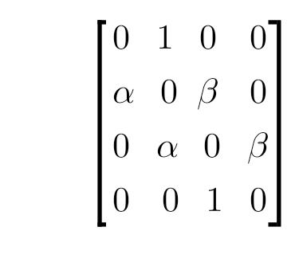Q-4. Recall the Markov process defined as "random walk with reflecting barriers". The four states of the process are 1, 2, 3 and 4. The transition probability matrix is as given below, with a = M/10. The initial probability distribution over states is (0, 1/2, 1/2, 0). What is the probability that the process is in state 2 after two time steps?

**Table of standard normal cumulative distribution**

|  |  |  |  |  |  |
| --- | --- | --- | --- | --- | --- |
| Index | z | F(z) | Index | z | F(z) |
| 1 | 0.00 | 0.5000 | 11 | 1.00 | 0.8413 |
| 2 | 0.10 | 0.5398 | 12 | 1.10 | 0.8643 |
| 3 | 0.20 | 0.5793 | 13 | 1.20 | 0.8849 |
| 4 | 0.30 | 0.6179 | 14 | 1.30 | 0.9032 |
| 5 | 0.40 | 0.6554 | 15 | 1.40 | 0.9192 |
| 6 | 0.50 | 0.6915 | 16 | 1.50 | 0.9332 |
| 7 | 0.60 | 0.7257 | 17 | 1.60 | 0.9452 |
| 8 | 0.70 | 0.7580 | 18 | 1.70 | 0.9554 |
| 9 | 0.80 | 0.7881 | 19 | 1.80 | 0.9641 |
| 10 | 0.90 | 0.8159 | 20 | 1.90 | 0.9713 |
|  |  |  | 21 | 2.00 | 0.9772 |